Sauve

Design Plan for Kidane Kidane

Web Programming 1

Marissa Cleroux

October 1st, 2023

Sauve

Sauve is a store to buy secondhand products, reduce waste by giving people a location to donate their unused clothes or products. Provide a place to buy items at a way cheaper price. Sauve is not here for profit. Every dollar earned goes right back into charity. It is a nonprofit store which means that every purchase you make directly goes to promote sustainability and help those in need.

This website is to provide a convenient online platform for users to buy second-hand items. It will contain a variety of categories, for example clothing, electronics, jewelry, and more. It provides a user-friendly platform with detailed listing. It is the perfect place to discover unique items and collectables. We donate most of our earnings to charity to ensure that your shopping choices are meaningful. Our team of experts will ensure that each item is of high quality, giving you access to unique and deserved items.

Home

As the name suggests, home will take you right back home. It is where you will see our featuring items and special deals most of the time.

Products

Products will take you to a category you can choose from. You will also have an option to sort items to your liking and more. Then so on it will sort out the items to be from the category you chose and sort it out too.

Contact

The contact us pages will have our information like phone numbers, email addresses and so on so that the user can reach out to us and give us feedback. There will be a form to fill out for the visitor. There will be social media links linked to our profiles, for example like Instagram, Facebook and twitter, so our users can be updated.

About Us

This page will have more information on our store. It will have the history of our store, for example, how did it start? What's our goal? And more information. Our leadership team, founders, executives and others play significant roles in our company's success. It will have photos and videos of your team members to connect with our audience. Our future goal and how we are going to continue to make this world a better place.

Donate

Our donate page will have reasons why donations are important and how it supports our non profit goal. It will have multiple donation options and one-time donations or monthly donations and choose a specific cause the user wants to support. It will include payment methods (debit, credit, PayPal, and more). Maybe put examples of past donors that helped someone else out there with their pictures and story about them.

Buy now

This page will be similar to the page products but won't have as many features, it will just be for browse you our items so you can just add to cart and buy quickly. (May change it to a cart option, I haven't decided yet I will see as I go on to make my website).

Target Audience

This website is mostly going to be for people who would like to go thrifting. Especially people who love shopping for unique items, looking for great deals and people who enjoy selling their own art or used items through donations. Age will most likely be young adults between 15-25 at most.



This is the logo for my website. Used canva.com

Colors

I wanted my website to be not too colorful

 #333232

#000

#fff

#b0f5b0

 (5, 243, 223)

Banner



Mobile Sketch

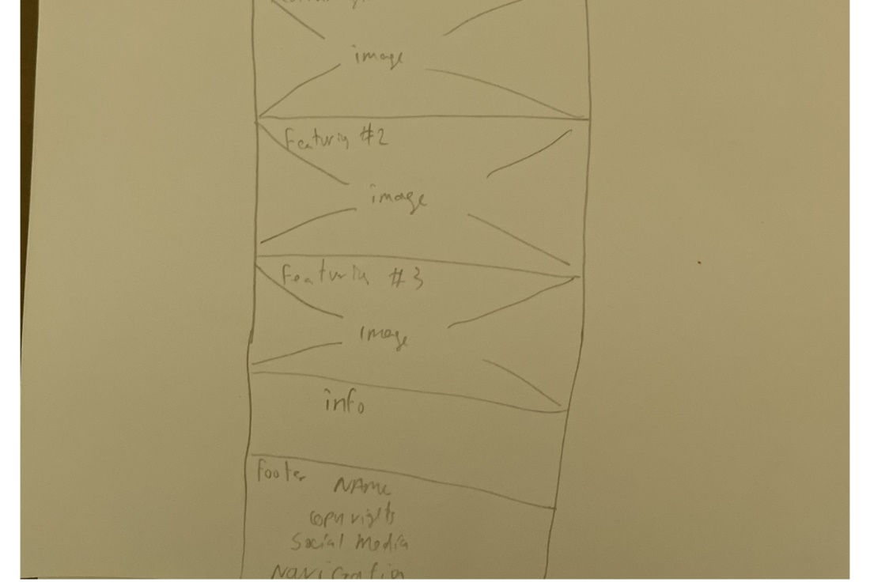

Desktop Sketch

